CHAPTER 31
ALTERNATING CURRENT
Discussion Questions
Q31.1 At the higher voltage, the same power can be transmitted at lower current so there is less 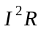 power loss in the transmission wires. The higher voltage is more of a safety risk.

Q31.2 The polarity of the source voltages reverses when the current direction reverses. Current always enters the terminal and exits the + terminal as it passes through the source. The moving charge always gains electrical energy as it moves back and forth in the source. At a resistive load the moving charges in the current always lose electrical energy as they pass through the load in either direction. The oscillating charge at the source causes oscillating charge at the load. Electrical energy is put into the circuit at the source and consumed at the load.

Q31.3 In the inductor or capacitor electrical energy is stored and then released back to the circuit. In the resistor electrical energy is dissipated by transformation to thermal energy and not returned to the circuit.

Q31.4 When the charge on the left plate is positive but decreasing in time 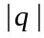 is decreasing so 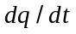 is negative. The current is clockwise so is negative and 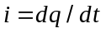 is correct. When the charge on the right plate is positive and increasing, is increasing. But refers to the charge on the left plate so is negative. A negative that is getting larger in magnitude corresponds to 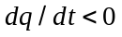. is clockwise so is negative and is correct. When the charge on the right plate is positive and decreasing, 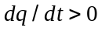 since is negative and decreasing in magnitude. is counterclockwise so is positive and is correct.

Q31.5 A resistor would dissipate electrical energy but no electrical energy is dissipated in the inductor. Electrical energy is temporarily stored in the magnetic field of the inductor but at a later time all this energy is returned to the circuit.

Q31.6 current to right through and increasing: is in the positive direction and increasing in magnitude so 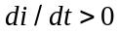. By Lenz’s law the induced emf in the inductor is directed to oppose the increase in the current. The induced emf is therefore to the left in Fig.31.8a and this corresponds to 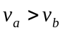.
current to the right through and decreasing: is in the positive direction and is decreasing in magnitude so 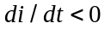. By Lenz’s law the induced emf in the inductor is directed to oppose the decrease in the current. The induced emf is therefore to the right and this corresponds to 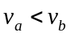. 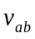 is negative and 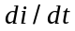 is negative so 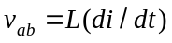 is still correct.
current to the left through and increasing: is in the negative direction and is increasing in magnitude so . By Lenz’s law the induced emf in the inductor is directed to oppose the increase in the current. The induced emf is therefore to the right and this corresponds to . is negative and is negative so is still correct.
current to the left through and decreasing: is in the negative direction and is decreasing in magnitude so . By Lenz’s law the induced emf in the inductor is directed to oppose the decrease in the current. The induced emf is therefore to the left and this corresponds to . is positive and is positive so is still correct.

Q31.7 No. The power factor is 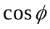, where 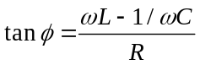. Mathematically, 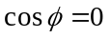 only if 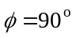. gives 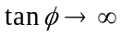. This happens if 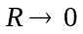. This is consistent with the equation 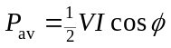 for the average power input to the circuit. As long as 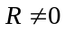 there is some electrical power consumed in the resistor and the power factor isn’t zero.

Q31.8 At any instant in time 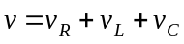. 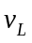 and 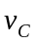 are 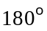 out of phase so have opposite sign. 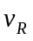 and 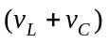 are 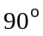 out of phase and 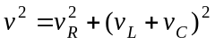. 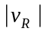 and 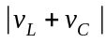 must each be less than the magnitude 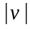 of the source voltage. But since 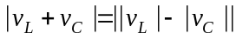, 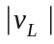 and 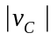 can each be larger than .
Q31.9 When the circuit is far from resonance 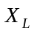 and 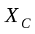 differ. So if 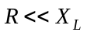 and 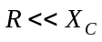, then it will also be true that 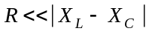. 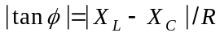, so 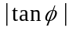 is large and is close to 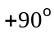 or 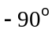. The power factor 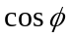 is close to zero. The current and source voltage are close to out of phase and little power is delivered by the source. Since is small, little power is consumed in the resistor and this agrees with little power delivered by the source.
Q31.10 See Q31.8. The voltages across the inductor and capacitor are out of phase, so at all times have opposite polarity and subtract from each other when the loop rule is applied. The net voltage at any time across the capacitor and inductor combination can’t exceed 120 V, but the capacitor voltage can be much larger than this.

Q31.11 The inductor doesn’t affect but it does increase the impedance of the circuit. 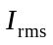 and therefore 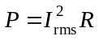 decrease.

Q31.12 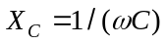. Inserting the dielectric increases 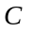 and therefore decreases . This in turn decreases . The rms current in the circuit increases and the bulb becomes brighter when the dielectric is inserted.

Q31.13 Inserting the iron rod increases the inductance . 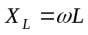 so increases and increases. This in turn decreases the rms current in the circuit and the bulb becomes less bright.

Q31.14 The impedance is 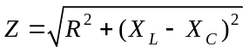. An increase in decreases and the bulb becomes less bright. A decrease in increases and the bulb becomes brighter. Whether 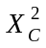 or 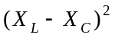 is smaller depends on the numerical values of and . Similarly, whether 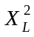 or is smaller depends on the values of and . The change in brightness, whether it increases or decreases, depends on the values of and , and these in turn depend on , and the frequency 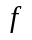 of the source.

Q31.15 Yes, this happens at the resonance frequency. At resonance 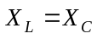 and 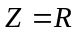with the capacitor and inductor present and also when both are removed.

Q31.16 No. The transformer works using the induced emf that results in an ac circuit. If a transformer is connected to a dc line there is no current or voltage in the secondary.

Q31.17 (a) 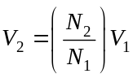. If 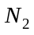 is doubled, then 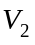, the voltage amplitude in the secondary, doubles. (b) The effective resistance of the secondary is given by 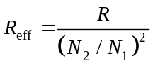. If is doubled the effective resistance is multiplied by a factor of and therefore decreases.

Q31.18 (a) The resonance angular frequency is given by 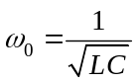. If and  are both doubled the resonance is halved. (b) The inductive reactance is 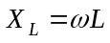. If is doubled then 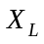 increases by a factor of two. (c) The capacitive reactance is 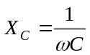. Doubling means 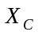 is halved. (d) The impedance is 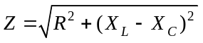. Since and are doubled but is halved, does not change by a simple factor of two.

Q31.19 The resonance angular frequency is . It is independent of . To double 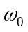, decrease and by multiplying each of them by .

